**Media Alert: iFi Audio to Showcase at CanJam SoCal 2024**

***Southport, UK, September 23, 2024—***[**iFi Audio**](https://ifi-audio.com/)**, an award-winning leader audio tech company that champions the purest sound quality, will be showcasing a curated range of portable and home digital-to-analog converters during the upcoming** [**CanJam SoCal 2024**](https://canjamglobal.com/shows/socal2024/) **show. From September 28 through 29th, iFi will be set up in the Grand Ballroom at booths D1 and D2 located inside the Irvine Marriott in Orange County, California.**



**Portable Audio**

The portable offerings include the recently launched powerhouse iDSD Diablo 2, the Go Bar Kensei with K2 Technology and tailored to perfection xDSD Gryphon. These three will be on display and connected to Sennheier’s HD820 headphone for listening demos. Alongside these products will be the fan-favorite Hip-Dac 3 and the GO Pods accompanied by the Meze 99 Classic and Meze Advars and Symphonium Meteor respectively.

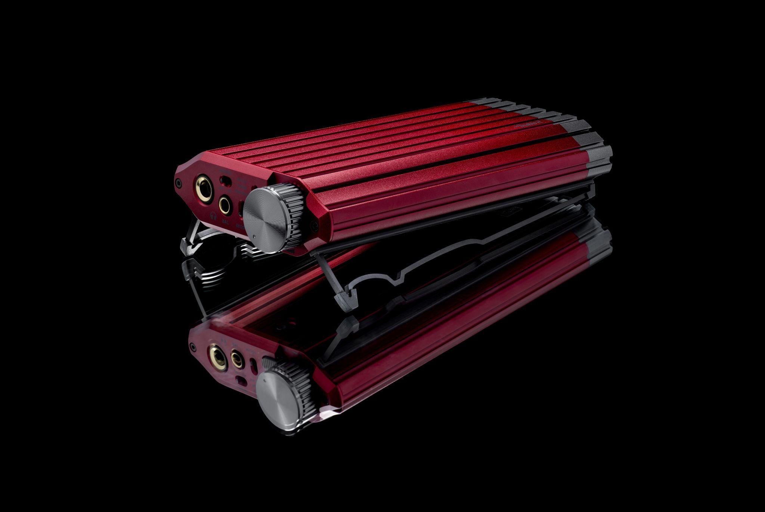

**Home Audio**

The versatile and latest iteration of the Zen DAC 3 will be available to listen to using the Meze 99 Classic. Attendees can also experience the xMEMS support from the Zen CAN 3 and get a taste for the world’s first lossless Bluetooth DAC/amp the Neo iDSD 2. Also on display will be the iCan Phantom connected to the Final D8000 and Audeze Carbon Electrostatic headphones.

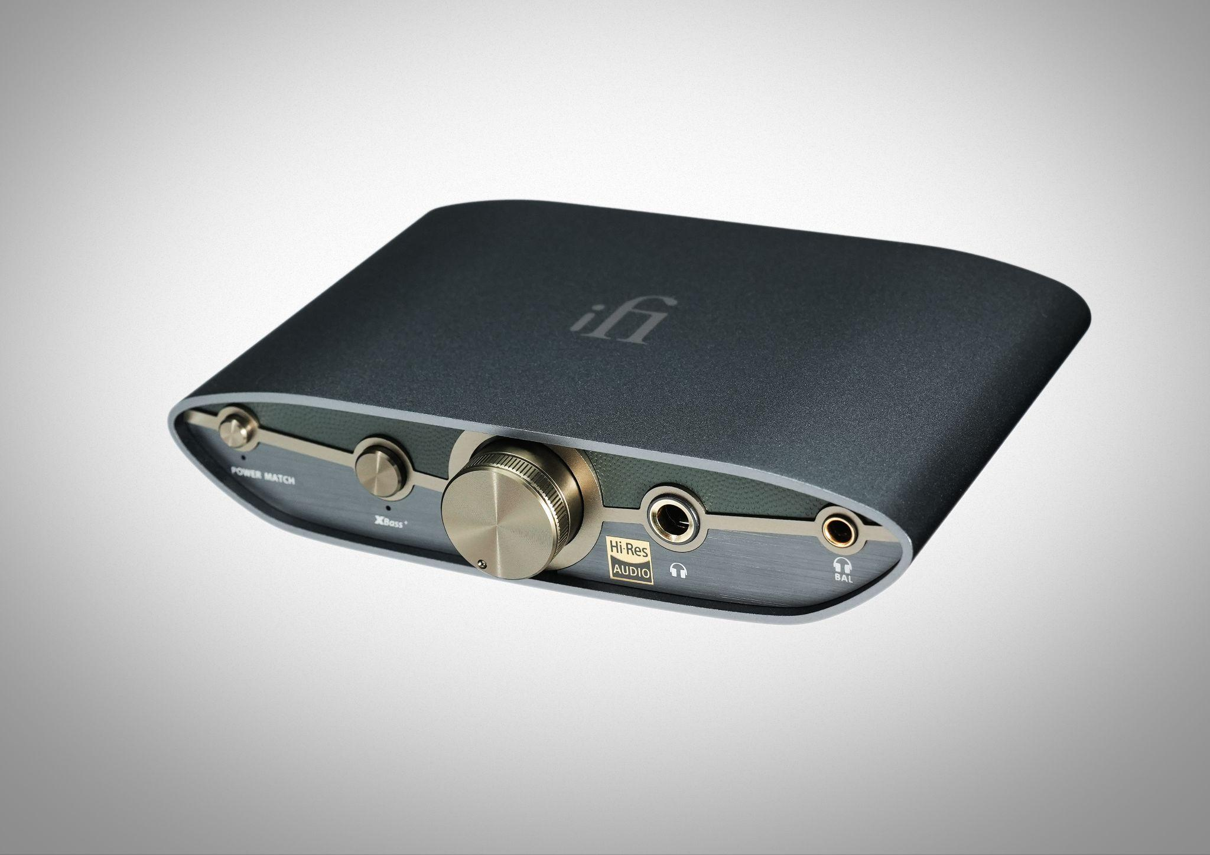

**For more information about iFi Audio and their offerings please visit,** [**www.ifi-audio.com**](http://www.ifi-audio.com)**.**

**Contact**

Shelby Coppola  
Hummingbird Media  
Public Relations  
shelby@hummigbirdmedia.com

**About iFi**

iFi is the sister-brand of Abbingdon Music Research (AMR) and is headquartered in Southport, UK. The two brands respectively design and manufacture portable, desktop and lifestyle audio products and high-end hi-fi components. Combined in-house hardware and software development teams and a ‘music first’ approach enable iFi and AMR to create advanced audio products that deliver new levels of design, functionality and performance at their respective price points. Since iFi’s formation in 2012, its products have earned many awards around the world, helping it to become one of the fastest-growing brands in its field.

[www.ifi-audio.com](http://www.ifi-audio.com)